BI
Mini Project
Health Care Analysis

Schema Design:
The Dimension tables are Dim_Country_Details, Dim_Hospital_Details, Dim_Survey_Details, Dim_Measure_Details. Fact Table is Fact_Patient_Survey.

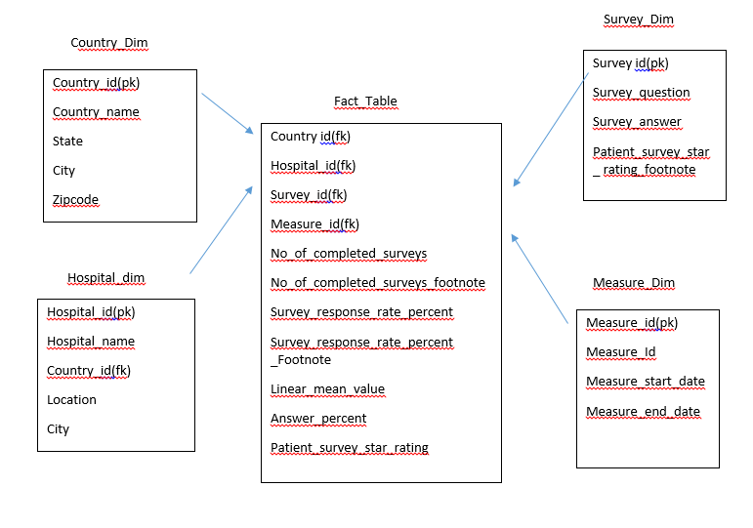

NOTE:
The datatype/length for the Dimension/Fact table attributes can be changed as required. Additional fields can be added, if required.

- Dim_Country_Details
This dimension contains names of all the Countries.
This snowflake table comprises of the following Fields:
- Country_Id(PK)
- Country_Name
- State
- City
- ZipCode

The Country_ID is a running sequence and unique number to be generated for all the countries.

- Dim_Hospital_Details
This dimension contains the details of the Hospital and the snowflake table comprises of the following Fields:
- Hospital_ID(PK)
- Country_Id(FK)
- Hospital_Name
- City
- Location

- Dim_Measure_Details
This dimension contains different measures values and the snowflake table comprises of the following Fields:
- Meausre_id(PK)
- Measure_Id
- Measure_Start_Date
- Meausre_End_Date

- Dim_Survey_Details
This dimension contains the survey details of the patient about the Hospitals and snowflake table comprises of the following Fields:
- Survey_Id(PK)
- Survey_Question
- Survey_Answer
- Patient_Survey_Star_Rating_FootNote

The Fact Table is :

- Fact Table contains the following fields.
- Country_Id(FK)
- Hospital_Id(FK)
- Measure_Id(FK)
- Survey_Id(FK)
- No_Completed_Surveys
- No_Completed_Surveys_FootNote
- Survey_Response_Rate_Percent
- Survey_Response_Footnote_percent
- Linear_Mean_Value
- Answer_Percent
- Patient_Survey_Star_Rating

Sample_Reports:- You can use any tool(Tableau , PowerBi, Python)

- Number of Surveys Completed by different Hospitals.
- Survey Response rate based on Measure id. Plot Measure ID vs Response Percentage where the data will be per Hospital.
- Top 3 Counties which have the highest survey rate.
- Top 10 hospitals based on Survey Response Rate
- County and city wise hospital rating through drill down report
- List the hospitals which are in same city
- Total Survey Response rate by all the Hospitals.
- Build a report that will give me some new insight from data

Streamlit Tutorial (optional)

